**PRANAV SANDEEP RAIKAR**

**D10A 43**

**EXPT 2:**

**AIM: Understanding Basic networking Commands: ifconfig ,ip,traceroute, tracepath, ping, netstat, ss, dig, nslookup, route,host, arp, hostname, curl or wget, mtr, whois, tcpdump**

**Study of different networking commands:**

1.ifconfig:Gets the ip address of our computer

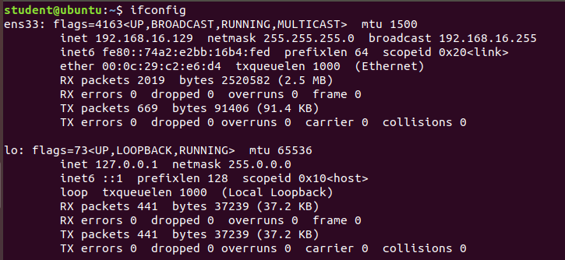

2.traceroute

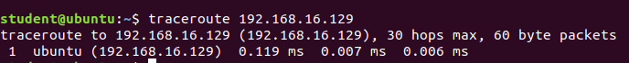

3.ping:checks whether there is a communication between two computers or with its own

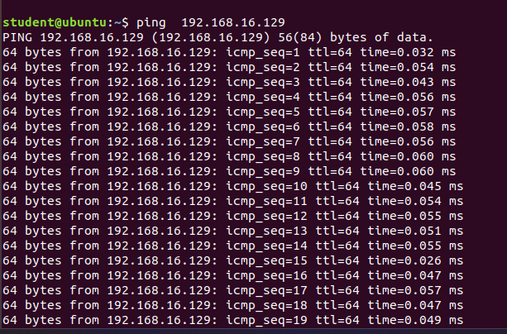

4.tracepath

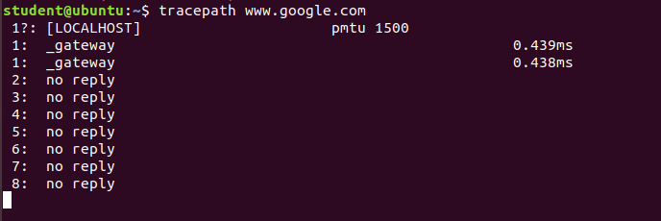

5.ss

6.dig

7.nslookup

8.route

9.host

10.hostname

11.curl

12.whois

13.tcpdump

Explain different networking commands: 1.ifconfig 2.traceroute 3.ping 4.tracepath 5.ss 6.dig 7.nslookup 8.route 9.host 10.hostname 11.curl 12.whois 13.tcpdump

1. ifconfig: This command is used to configure the network interface of a system. It is used to assign IP addresses to interfaces, enable or disable interfaces, and display information about network interfaces, such as status, IP address, and MAC address.
2. traceroute: This command is used to determine the route taken by packets across an IP network. It shows the sequence of intermediate devices (e.g., routers) a packet passes through to reach its destination.
3. ping: This command is used to test the reachability of a networked device. It sends an echo request packet to a specified IP address and waits for a reply. The time it takes for the reply to arrive is used to determine the network latency.
4. tracepath: This command is similar to traceroute, but it uses the ICMP(Internet Control Message Protocol (ICMP) protocol instead of the UDP( User Datagram Protocol) protocol.
5. ss: This command is used to show socket statistics. It provides information about network connections, including the status of a connection, the local and remote addresses, and the process ID of the program that opened the connection.
6. dig: This command is used to query the DNS (Domain Name System) to find information about host names and IP addresses. It can be used to query a specific domain name, to retrieve information about the DNS servers for a domain, or to perform a reverse lookup (finding the host name for a given IP address).
7. nslookup: This command is used to query the DNS to find information about host names and IP addresses. It is similar to dig, but it has a simpler interface and is often used interactively.
8. route: This command is used to display or modify the routing table of a system. The routing table contains information about the routes a system uses to forward packets to their destination.
9. host: This command is used to query the DNS to find information about host names and IP addresses. It is similar to dig, but it has a more user-friendly output.
10. hostname: This command is used to display or set the host name of a system. The host name is a human-readable string that identifies a system on a network.
11. curl: This command is used to transfer data from or to a server using various protocols, including HTTP, FTP, and SMTP. It can be used to download files, send HTTP requests, or perform other network operations.
12. whois: This command is used to query the whois database to find information about the owner of a domain name or IP address. It can provide information about the administrative and technical contacts for a domain, as well as the dates of registration and expiration.
13. tcpdump: This command is used to capture and display network traffic. It can be used to capture packets on a specific interface, to filter the packets based on criteria such as source and destination IP addresses, and to display the contents of packets in a human-readable format.